2a) Creating a VM and adding Storage, Memory, and Network to a VM

Aim:
To create a VM and adding storage ,memory and network to a VM in the oracle virtual box
Steps:
- Open Oracle VM VirtualBox Manager and Click the "New" button
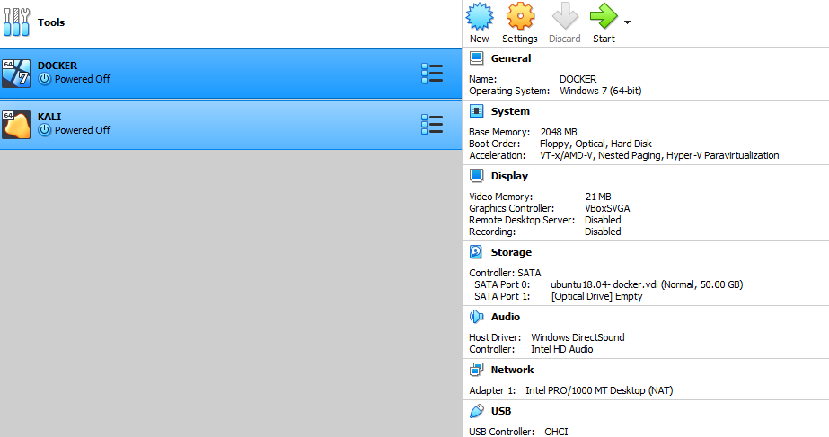
2) Fill the name: (KESHO_2A) Type: Linux Version: Ubuntu (64-bit) or your chosen OS and Click Next
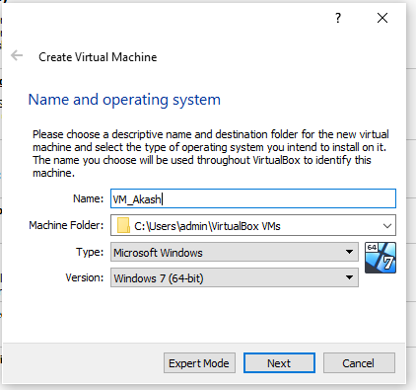
3) Allocate Memory (RAM) .Set the memory size 4gb has been set below Don’t exceed 50% of your physical system RAM Click Next

4)Click use an existing virtual hard disk. Click Next Dynamically allocated → Click Next Set disk size (e.g., 20 GB)Click Create

5) Configure Network Adapter Go to Settings → Network Ensure Adapter 1 is: Enabled Attached to:Bridged Adapter (for internet + LAN access), or Host-Only Adapter (for communication with host only) Click OK Then new vm has been created
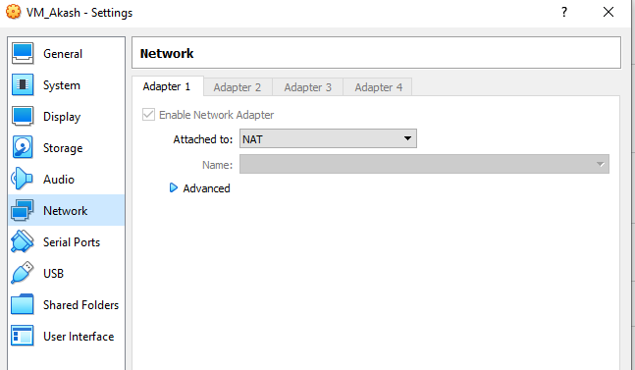
Execution of java program to test the execution time between vm (Ubunttu) and host(Windows)
1)To find the sum of digits between 1 to max of long datatype
Steps to Execute in Ubuntu (Virtual Machine)
- Open the Terminal.
- Create a Java source file using the command:
gedit filename. java
- Type the Java program in the Gedit editor.
- Save and close the editor.
- Compile the program using:
javac filename.java
- Execute the program using:
java filename
Code:
Execution time in Linux
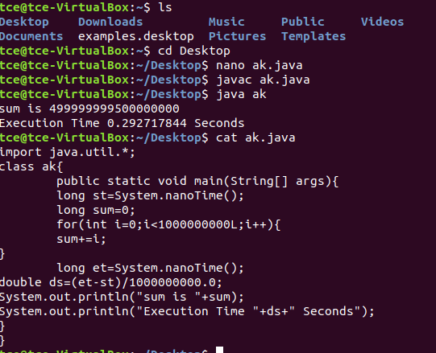
Execution time in Windows
Steps:
- Open notepad in windows.
- Type the program and save it as filename.java
- Open Command Prompt in windows
- Navigate to the folder containing the Java program:
cd <path_to_program> example:D:/
- Compile the program: javac filename.java
- Run the program: java filename
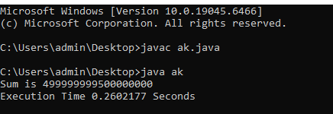

From the above the execution time in linux is 0.29 s where the time taken by the windows is 0.26 this clearly tells that the windows host is faster than the linux vm

RESULT:
Thus the Creation of VM and adding Storage, Memory, and Network to a VM has been created successfully and output has been verified.

2b) VM-VM ping, VM-Native Ping
Aim:
To check the victim or target is alive between VM -VM and VM-native (host) using the ping command .
Steps: Before ping commands
- Both VMs are Powered ON
- Both are connected to the same network (e.g., Host-Only or Bridged)
- Each VM has a valid IP address (like 192.168.56.x)
- Firewall is disabled or ICMP is allowed

Find IP Addresses
  - Using ip a or ifconfig in VM
  - Using ipconfig in windows
To enable VM-to-VM and VM-to-host ping communication in VirtualBox, first set both VMs' network adapters to "Host-Only Adapter" (e.g., vboxnet0) via VirtualBox → Settings → Network. Then, start both VMs and run ip a inside each to find their IP addresses (usually 192.168.56.x). On each VM, disable the firewall using sudo ufw disable and optionally flush iptables with sudo iptables -F. On the Windows host, enable ICMP ping by opening "Windows Defender Firewall with Advanced Security", going to Inbound Rules, and enabling "File and Printer Sharing (Echo Request - ICMPv4-In)". Now, use ping <other_VM_IP> from one VM to the other, and from the host, use Command Prompt to ping each VM’s IP (e.g., ping 192.168.56.101)

1)VM – NATIVE:
To check the target is alive between the host and vm using ping commands
IP address of windows:
Ip address of linux was 127.0.0.1
Using ping checking the vm is alive or not (ping 127.0.0.1)
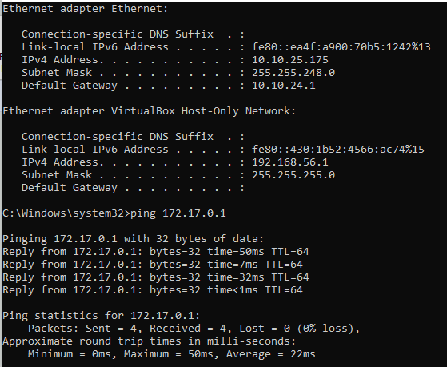
Ping for windows:
Using ping checking the host is alive or not (ping 192.168.56.1)
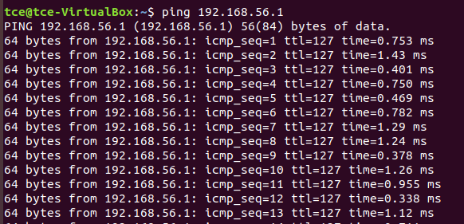
VM- VM
I am using linux (one was ubunttu) and another was (Kali linux )
Ping in Linux ubunttu:
Using ping 10.0.2.15 (Checking the kali linux is alive or not using ping in ubunttu)
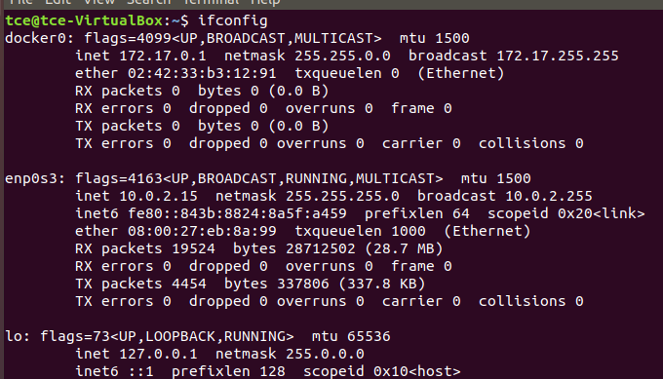
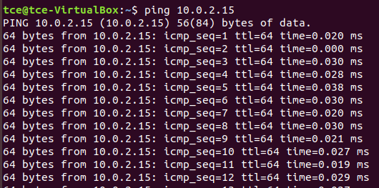
Using ping 172.17.0.1 (Checking the ubunttu linux is alive or not using ping in kali linux)
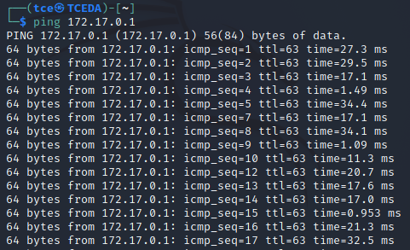

RESULT
Thus the checking the victim or target is alive between vm -vm and vm-native using the ping command has been executed successfully and output has been verified.

